Google Home Project Handout:

Randyll Bearer, Raj Patel, Zachary Barlotta

**Technologies Used:**

- **Google Chrome Browser:**

- Location Enabled

- Version 62.0.3202.94

- **Actions:**

- Google Assistant Proprietary Dev./Testing Software

- console.actions.google.com

- **Dialogflow:**

- Google Assistant Proprietary Dev. Software

- console.dialogflow.google.com

- **Nodejs:**

-JavaScript Framework

- Version 6.11.4

- **Firebase:**

- Cloud Function Deployment Software

- Version 3.13.1

- **Github:**

- Version Control Software

- Our Repository: https://github.com/rlb97/Capstone-Project

**Helpful Links:**

- <https://developers.google.com/actions/dialogflow/first-app>

- <https://miningbusinessdata.com/step-by-step-guide-to-api-ai/>

- Refers to Dialogflow as API.ai (the old service before it was replaced) but has

Updated examples for Dialogflow.

**Terminology Used:**

- **Google Assistant:** Google’s Voice Assistant AI. Can be run on top of any semi-modern Android device. Used in this project as a way to facilitate communication with a user through voice-to-text and text-to-voice conversions. Provides both text and voice feedback. Can be tested and simulated through the console.actions.google.com emulator. Communicates with the **Fulfillment** through JSON interchange.

- **Google Home:** Google’s hands-free and text-free home device, runs the **Google Assistant** to handle all functionality. Our goal for this project was to allow our software to be ran on this device.

- **Action:** A specific ‘skill’ that the **Google Assistant** possesses which can handle a specific user request, i.e. ‘Check the Weather’, ‘Play a Song’, or ‘Talk to Our Yelp Project’. Upon receiving a user request the **Google Assistant** tries to match that request with the best matching **Action**, which then asks the user for an **Intent**. Can be created through console.actions.google.com.

- **Intent:** A conversation handler which handles various user requests for a given **Action**, i.e. ‘Find Pizza near me’ or ‘Look up Piada’. An **Action** can have any number of **Intents**, allowing an **Action** to handle any number of requests. Once selected, an **Intent** will fulfill a user request by calling the appropriately mapped function in the **Fulfillment**. Can be created through the **Dialogflow** software at console.dialogflow.google.com.

- **Fulfillment:** The remotely hosted code which handles user requests. Composed of cloud functions which have been mapped to **Dialogflow** Intents. Handles all ‘Program Logic’ and does the majority of the work for the software. For our project, our **Fulfillment** was programmed in **Nodejs** and deployed through **Firebase**.

- **VagueSearch()**: One of the three implemented searches in our **Action**. **VagueSearch()** allows for the user to search the Yelp API for vague categories of food, i.e. Italian, Sushi, Steakhouse.

- **DirectSearch()**: One of the three implemented searches in our **Action**. **DirectSearch()** allows for the user to search the Yelp API for specific businesses, i.e. Piada, McDonald’s, Union Grill.

- **RandomSearch()**: One of the three implemented searches in our **Action**. **RandomSearch()** returns a randomly selected restaurant near the user based off of the Yelp API’s best_match feature.

- **ActionMap**: A Map object created in the **Fulfillment**. Maps **Action Intents** to functions in the **Fulfillment** so that the appropriate code gets called for each **Intent**.

- **Entity:** A variably-filled keyword which triggers **Intents**.

**Sample Conversation**



















**Dialogflow Rundown**: **Main**

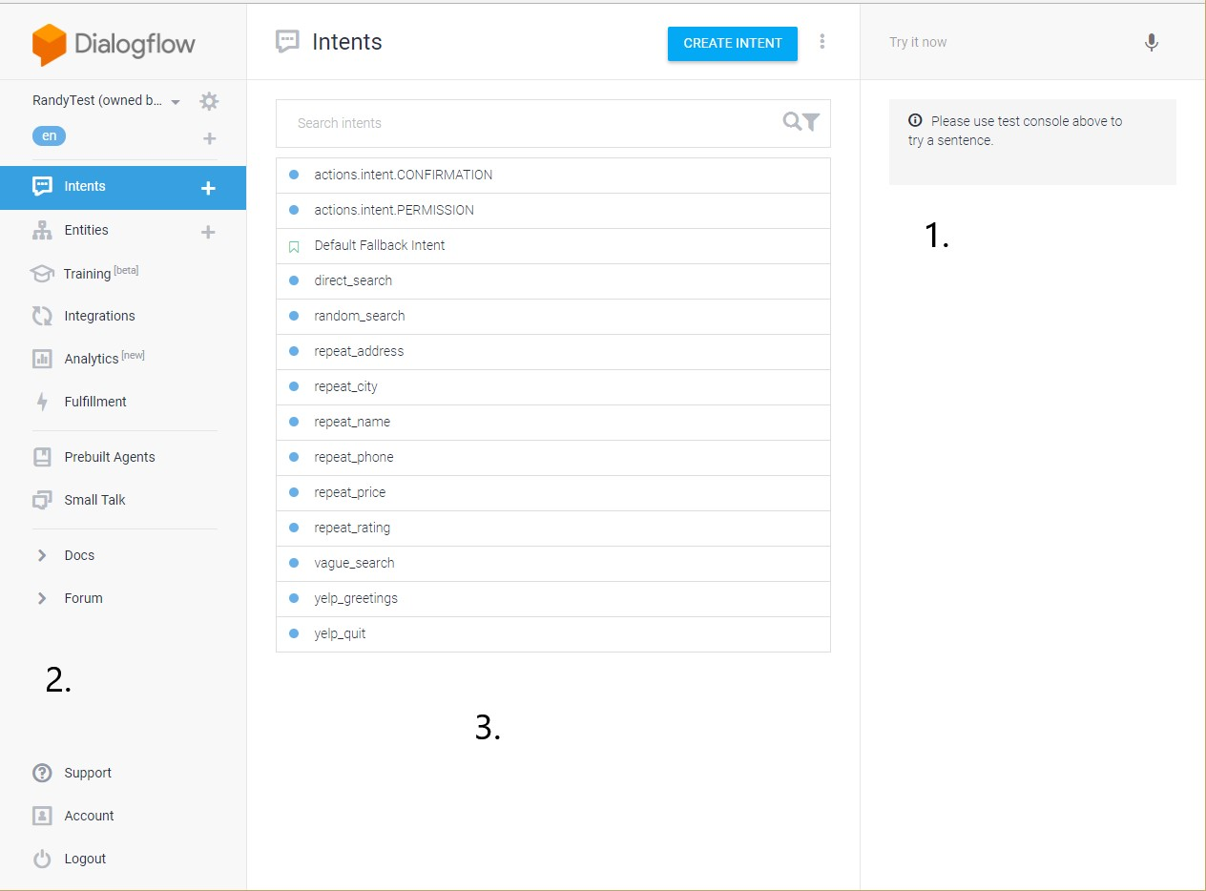

**1.** A text parser for **Intent** testing purposes. Will show you which **Intent** will handle your input string.

**2. Dialogflow** sidebar, allows you to switch between different tabs. This screenshot was taken on the **Intents** tab.

**3.** List of **Intents** set up for this specific **Action**.

**Dialogflow Rundown: Intent**

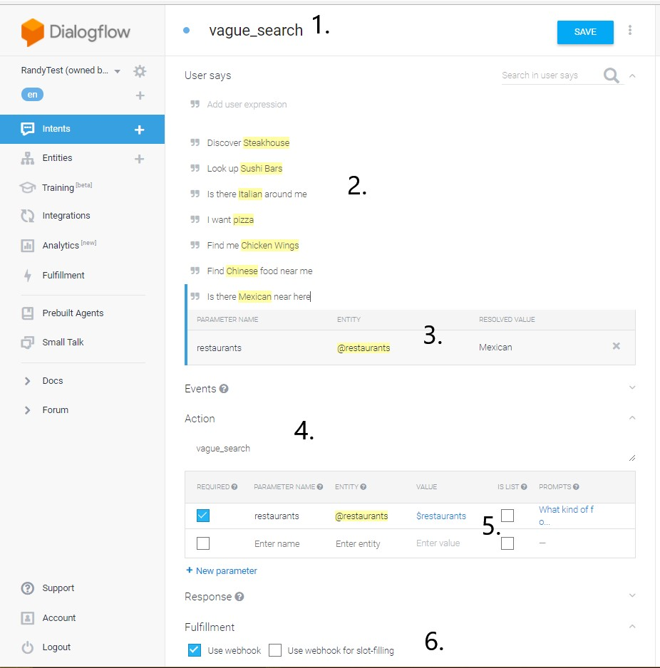

**1.** Name of the **Intent** you are working on.

**2.** List of user requests which will trigger the **Intent.**

**3.** List of **Entities** which the user request must include.

**4.** Name of the function to be mapped in the **Fulfillment**

**5.** List of arguments to be passed to the **Fulfillment**. We pass the “Restaurants” **Entity** here so that we know which specific restaurant the user wants to look for in the **Fulfillment**.

**6.** “Use webhook” Tells our **Intent** to run the external code in the **Fulfillment**.

**Dialogflow Rundown: Entities**

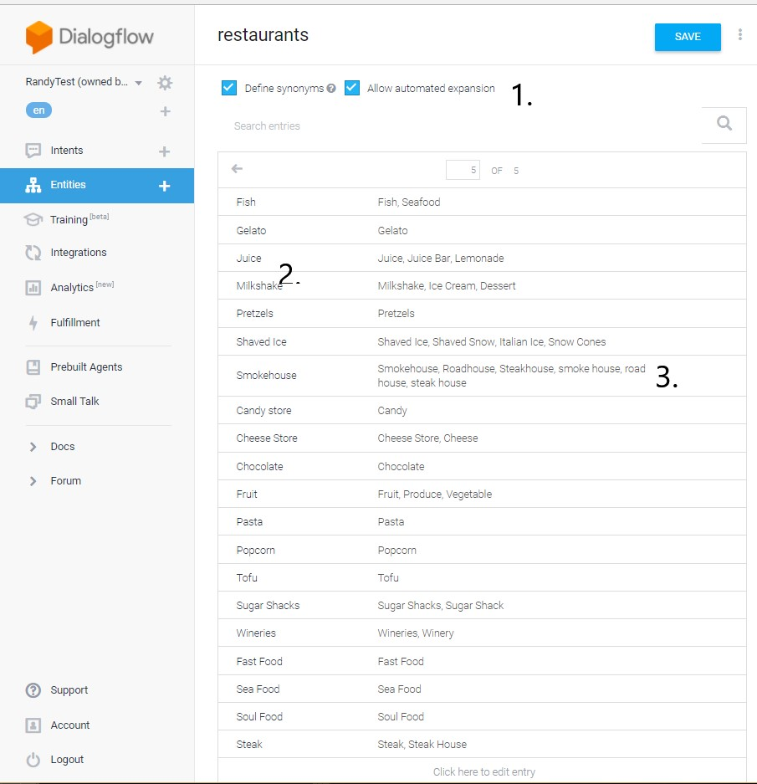

**1.** “Allow automated expansion” tells **Dialogflow** to go and provide their own synonyms.

**2.** The specific word which will fulfill the **Entity** requirement for the user request to be handled by an **Intent**. For example, if the **Intent** is looking for a request such as “Find @restaurant near me”, then the user request “Find Milkshake near me” would trigger the **Intent**.

**3.** The list of synonyms which will also trigger the **Intent** but pass the value of the parameter name. I.e., “Shaved Snow” would pass “Shaved Ice” to the **Fulfillment**.

**Dialogflow Rundown: Fulfillment**

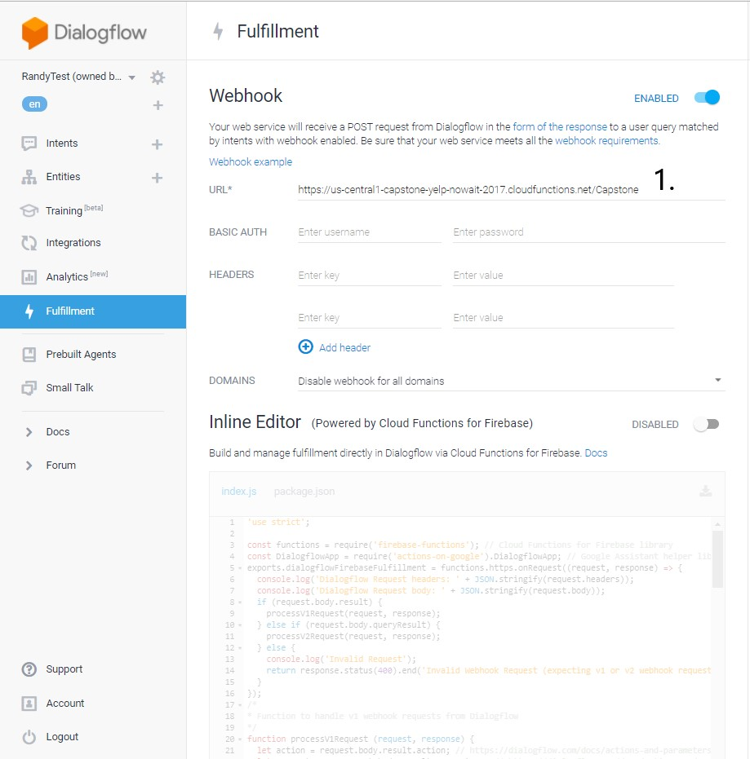

**1.** The URL which points to your cloud hosted **Fulfillment**. For our project we got this URL from **Firebase** automatically after deployment.

**Dialogflow Rundown: Integrations**

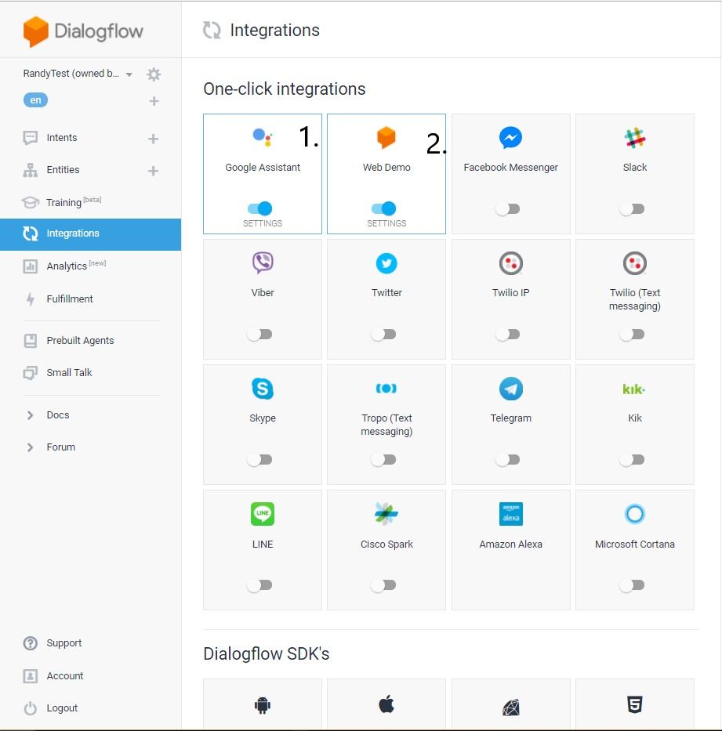

**1.** To update the version of your current **Action** that you want to test, you must click on “Google Assistant”, “Test”, then “View” to open a new tab with the simulator on it.

**2.** “Web Demo” must be activated in order to the simulator to work properly.

**Actions Simulator Rundown: Main**

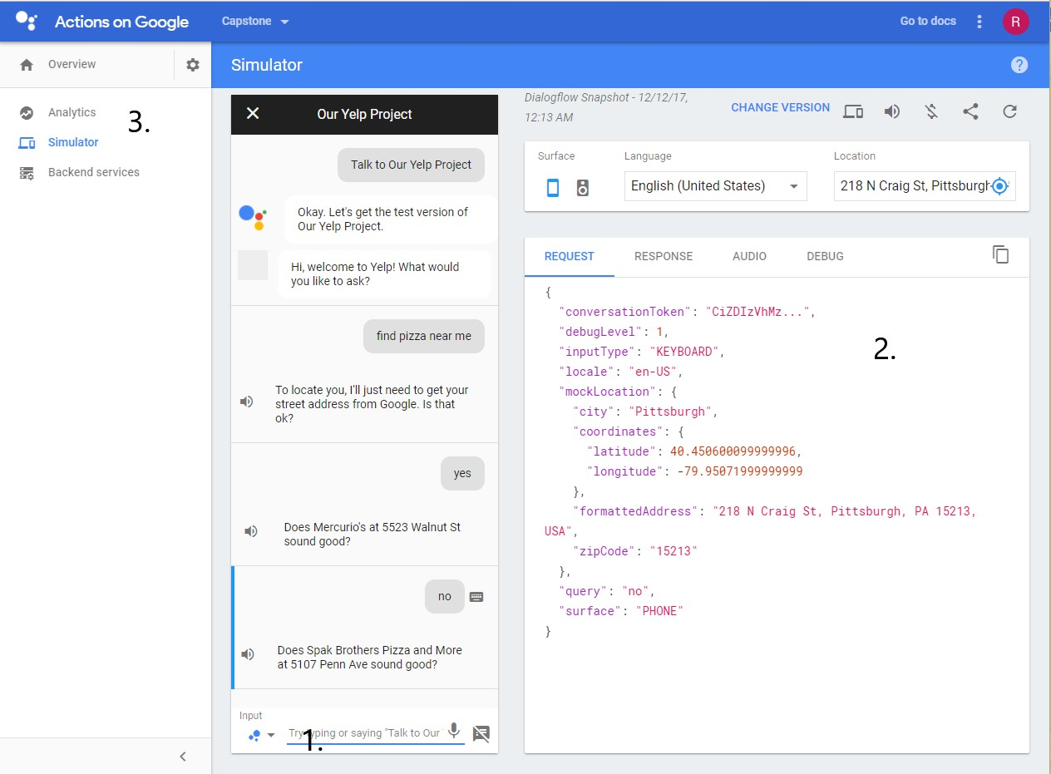

**1.** Input console. Allows you to enter in requests through either text or speech.

**2.** Debug window. Each tab provides different debug information. Working as of 11/20/2017.

**3.** Sidebar. “Analytics” Allows you to edit the meta-information for your **Action**/Project, such as Title, author, description, summary, and also allows you to publish **Actions**.

**Firebase Rundown:**

- To initialize **Firebase** for a directory, please refer to the first link under **Helpful Links**

For a tutorial on getting the deployment service set up.

- To deploy the contents of the current working directory, use the following command:

firebase deploy --only functions

Other keywords after “--only “ may be used depending on your requirements, but for

Our project we exclusively used “functions”.

- **Firebase** will then display the results of your deployment attempt. If your

Deployment was successful, then you will be displayed a URL to be copied

Into the **Fullfilment** tab in the **Dialogflow** sidebar.

- To debug console output from the **Firebase** server, use the following command:

firebase functions:log

Which will print the results of your last run **Fulfillment**.

**Misc. Details:**

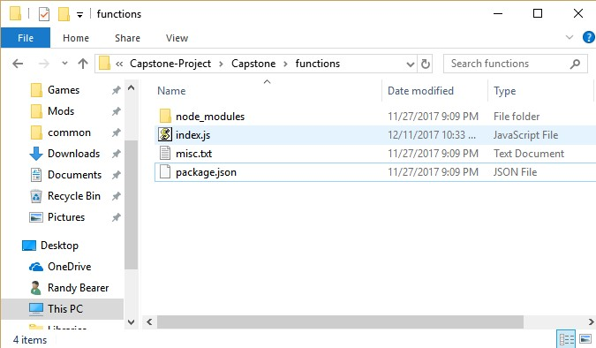

- The folder/working directory you should try to deploy from should be named “functions” if you are attempting to “deploy --only functions”.

- Index.js will contain the code for you fulfillment. Other files may be used as long as they are included by Index.js.

- Package.json will contain the meta-information for your deployment. E.g. Author, Name, Dependencies, etc.

- Misc.txt should be used for any miscellaneous information you want to persist in the directory.